08

**Fall**

**GP GENIE**

SEIS 610 Final Project Report: GP Genie

Ujin Han Ι Susan Mairs Ι Li Wang Ι Justin Florkiah Ι Roger Peterson Ι Felista Mpanga

Table of Contents

Project Plan 4

Problem Description 4

Problem Title 4

Problem Summary 4

Detailed description 4

Approach 5

Requirements Analysis And Preliminary System Design 5

Weekly Software Configuration Management Files And Traceability 5

Work Plan 5

Roles & Responsibilities 5

Milestones & Schedule 6

Final System Design 7

System Testing Plan and Test Results 7

System Testing Plan 7

Test Results 7

Lessons-Learned 7

Requirements Analysis 7

System Design 7

Program Design 7

Coding 7

Unit and Integration Testing 8

System Testing 8

Acceptance Testing 8

Operation & Maintenance 8

Short User Manual 8

Description 8

Instructions 8

Project Summary 9

Post-Project Analysis 9

Reviewing the Project Objective 9

Self-Analysis 9

Revisiting the Original Project Plan 9

Analyzing What Happened During The Project 10

Review the Project Outcomes 10

Appendix A: Project Related Materials 10

A1. Weekly SCM files/folders (in plain text file) 10

A2. Visual Materials (PPT and printed PPT) 10

A3. Post-project Analyses (in plain text file) 10

# Project Plan

## Problem Description

### Problem Title

SEIS 610 – Generic Programming (GP) Project

### Problem Summary

Generating a function that is equivalent to the target function

### Detailed description

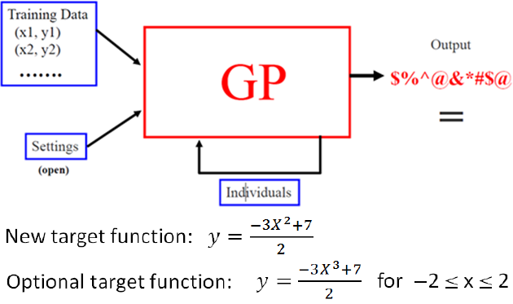

* Generate a set of training set to evaluate the fitness. A set of random input (x) will be generated. Evaluate the input using the target function, to provide the training set.
* Generate a set of initial inputs of random compositions of the function of the problem.
* Execute each program in the population and assign it a fitness value according to how well it solves the problem. The fitness can be calculated as the delta (sum of error) of the function and the target function. Higher delta leads to a lower fitness.
* If there is a function that meets the termination condition (delta =0), program stops.
* If termination condition does not meet, the following steps will be executed
  + **Natural Selection**: The solutions with good fitness value survive to the next generation with high probability. Solutions will lower fitness value perish with high probability.
  + **Crossover**: Two solutions chosen with natural selection to generate new solutions
  + **Mutation**: replacing part of the solution with random generated new solution to reproduce new solutions
  + Repeat the fitness and selection step until termination condition meets, or time is over

### Approach

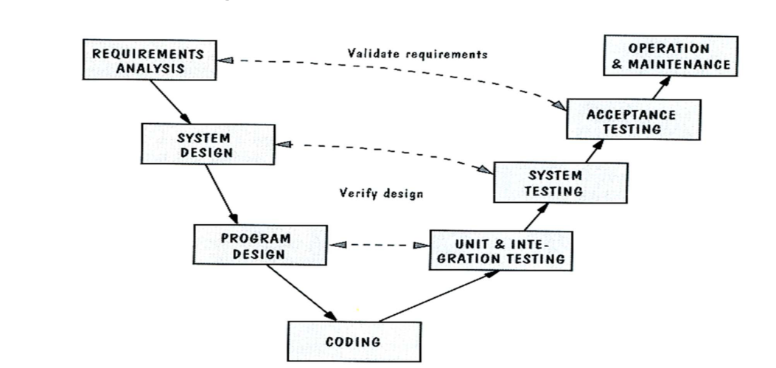The project will follow the “V-module” during the software development.

The client requirement should be documented and captured during the development

## Requirements Analysis And Preliminary System Design

The team created an Software Requirements Specification (SRS) document to capture requirements, requirements analysis in model diagrams and a data dictionary, and the preliminary design in a class diagram. A hard copy of this SRS document “SRS GP Genie.docx“ is attached and submitted with this final report.

## Weekly Software Configuration Management Files And Traceability

Need to say HOW we did this – Roger

For weekly SCM and traceability, an Excel spreadsheet was created on Google Docs that allowed access to each member to update as the project progressed. T

## Work Plan

### Roles & Responsibilities

The following is a list of roles and who is responsible for each role.

|  |  |
| --- | --- |
| **Roles** | **Name** |
| Project Management & Communications Liaison | Ujin Han |
| Process Leaders | Ujin Han  Justin Florkiah |
| Development Leader | Li Wang |
| Technical Leaders | Roger Peterson  Felista Mpanga |
| Measurement Leaders | Susan Mairs  Ujin Han |
| Capture Requirements | Susan Mairs |
| Coding | Li Wang |
| Code Review | Susan Mairs |
| Testing | Felista Mpanga |

For the roles with multiple team members listed, they will share the responsibilities of that particular section of the project. As the project goes on and more responsibilities come up, those roles will be added. During the project, if a certain team member is struggling with the given task, others with knowledge and availability will assist in its completion.

### Milestones & Schedule

To complete the project with changes in requirements by December 14th, the team has following milestones and dates set.

|  |  |
| --- | --- |
| **Milestone** | **Due Date** |
| Requirements & preliminary system design finalized; Project Plan completed and submitted | October 26, 2013 |
| All complements needed for program design finalized | October 29, 2013 |
| Working software | November 19, 2013 |
| Testing software | November 26, 2013 |
| Revised working software with new requirements | December 7, 2013 |
| PowerPoint presentation completed | December 12, 2013 |
| Project completion and deliverables submitted | December 14, 2013 |

The team has a weekly meeting on Tuesday evenings at 6 pm until the end of the semester to check-in and discusses the progress of the project. These meetings will last from an hour to two hours depending on the subject of the meeting at the time. Additional meetings will be scheduled as the team sees fit.

# Final System Design

# System Testing Plan and Test Results

## System Testing Plan

## Test Results

# Lessons-Learned

For each section of the project, the team discussed what was and was not effective in completing the task and promoting workflow.

## Requirements Analysis

## System Design

## Program Design

## Coding

## Unit and Integration Testing

## System Testing

## Acceptance Testing

## Operation & Maintenance

# Short User Manual

## Description

GP Genie is a generic programming software that aims to generate an equation equivalent to the target function of the user’s choice, either A or B. The user inputs the following basic criteria: (1) Population Size, (2) Maximum Tree Depth, (3) Fitness Selection Percent, (4) Time Limit, and (5) Program: Required Function or the Optional Target Function.

## Instructions

1. Open GP Genie.
2. Choose and input population size, between 100 and 1,000.
3. Input maximum tree depth, between 5 and 20.
4. Input fitness selection percentage, between 10% and 30%.
5. Input time limit, between 5 to 15 minutes.
6. Choose which program to run, either Required Function or the Optional Target Function.
   1. Target Function A: Y = $\frac{-3X^{2}+7}{2}$
   2. Optional Function B: Y = $\frac{-3X^{3}+7}{2}$ for x -2 ≤ X ≤ 2
7. The program is designed to choose the training data associated with the equation, according to the user’s choice.
8. Within the maximum time limit, the program will provide the fittest equation and its fitness value.

# Project Summary

# Post-Project Analysis

## Reviewing the Project Objective

Under this section, all discussion should revolve around the objective, as the objective should be the measuring stuck by which the project success gauged.

## Self-Analysis

Under this section, everyone is held accountable beginning with the project manager's performance, individuals, and group as a whole. Also, not just generalizations, but specific things, good and bad, that contributed to the project's success or failure. And/or any need for improvement.

## Revisiting the Original Project Plan

Under this section, I will outline the outcomes that were to be achieved by the project , questions that were been asked and/or any lack of clarity among the team members. If everyone was clear on the specifics and expectations, how it lead to major point of improvement for the project.

## Analyzing What Happened During The Project

Reviewing the data

Everyone would account for mistakes and deficiencies as well as successes. Mistakes would be highlighted and discussed.

## Review the Project Outcomes

Under this section, we will say which success criteria we met and which we didn't. Also, we will generate a "Lessons Learned" sheet - List what was gained from the project objective -- the lessons that the team learned. What would the team do differently next time? What would they do the same?

We are all more successful when we contribute to the learning and success of others.

# Appendix A: Project Related Materials

## A1. Weekly SCM files/folders (in plain text file)

## A2. Visual Materials (PPT and printed PPT)

## A3. Post-project Analyses (in plain text file)